**Setting up working environment**

**Setting java**

Run downloaded jdk file (eg jdk-8u181-windows-x64) (in the program folder, the jdk and jre folders will created)

Set environmental variables (set JAVA_HOME and on the path set the of the jdk)

Both in the JDK and JRE folders installed paste and override the security file “cacerts”:

C:\Program Files\Java\jdk1.8.0_181\jre\lib\security

C:\Program Files\Java\jre1.8.0_181\lib\security

**Setting up maven**

Download the maven folder and place in in programs file (optional)

Set environmental variables (set MAVEN_HOME and on the path set the of the maven folder)

Copy and paste the m2 file (if you have) into your user.

Make sure you the two setting files inside the m2 folder

**Setting up Git**

Download the git setup file and install git

Set environmental variables (set only on the path the bin folder)

See the diagram for **Environmental variable**

Setting **java, maven and git**

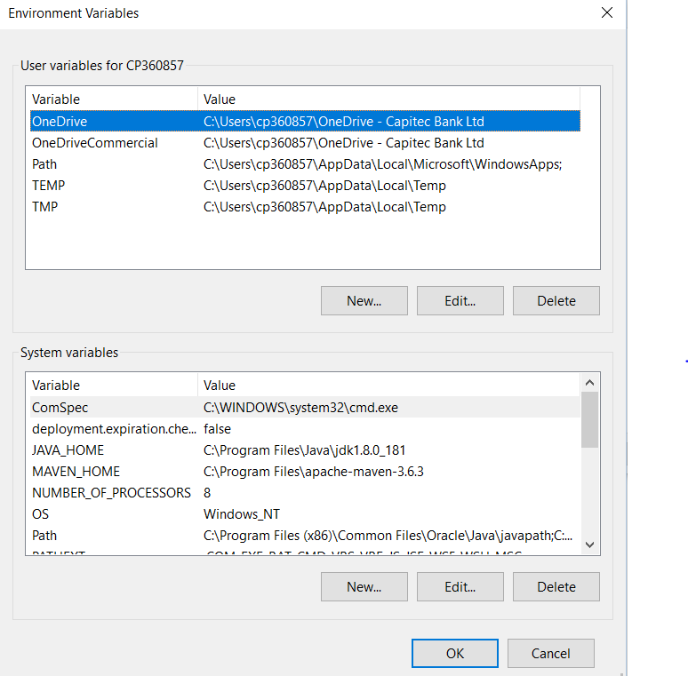

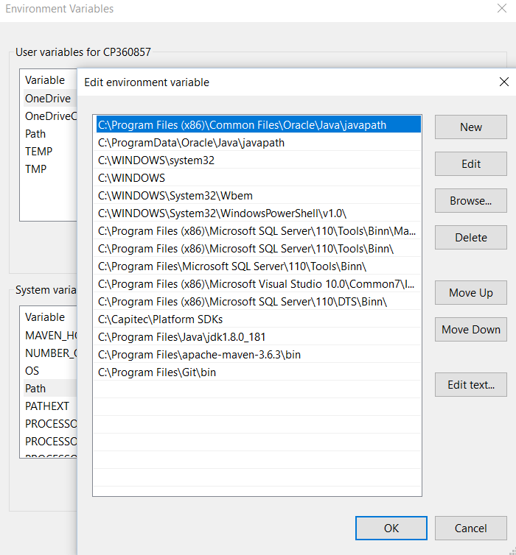

**Setting intellij**

Download the intelli j setup and install

On settings set the SDK to point to the JDK folder installed

Set the maven path to point to the correct maven folder

On version control, select git and point the path to the git.exe file when it is installed in your program files.

Clone the project on bit bucket (if complaining about certificate run the command:

git config --global http.sslVerify false)

To clone all E-channel projects: dev.bat

Open the project on intellij

Before running run the commands or add as configuration on intelli j:

These are for adding in the configuration (you can run these on the command line by just adding mvn in front of each command):

clean install -U -DskipTests -Pcompress-css

//This is to clean the project and skipping the tests

Or

clean install -Pci_tests

jetty:run //this is for running or deploying localy

jetty:run -f pom.xml

//this is forcing running

On command line you can just use the command: mvn clean jetty:run

To deploy localy projects like message sender service, run command:

mvn clean -DskipTests install -Dbamboo_build_version=99.99.99.99-SNAPSHOT

To get the changes that is deployed on mbank or iBank, specify the version artefact on the pom file of ibank or mbank (99.99.99.99-SNAPSHOT)

clean install -U -DskipTests -DskipIntegrationTests

clean install -U -DskipTests -DskipIntegrationTests

mvn clean install -DskipTests -Dbamboo_build_version=0.0-SNAPSHOT

Intellij Diagram

Project Structure. Set the SDK to point to the JDK folder installed

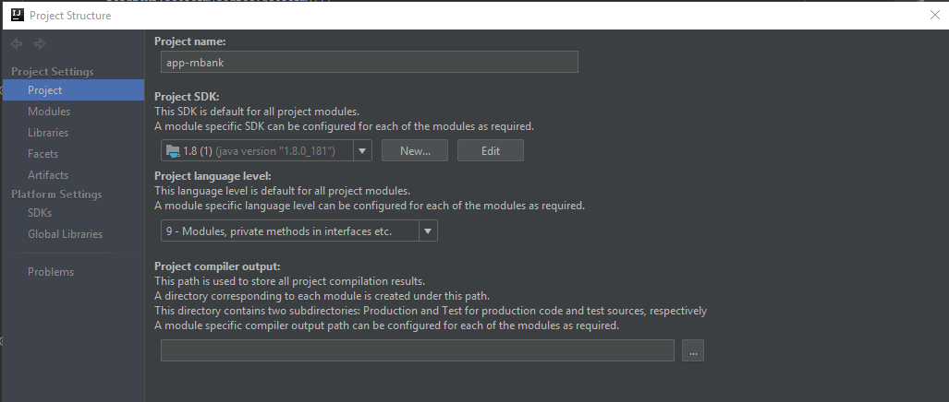

Settings. Set the maven path to point to the correct maven folder

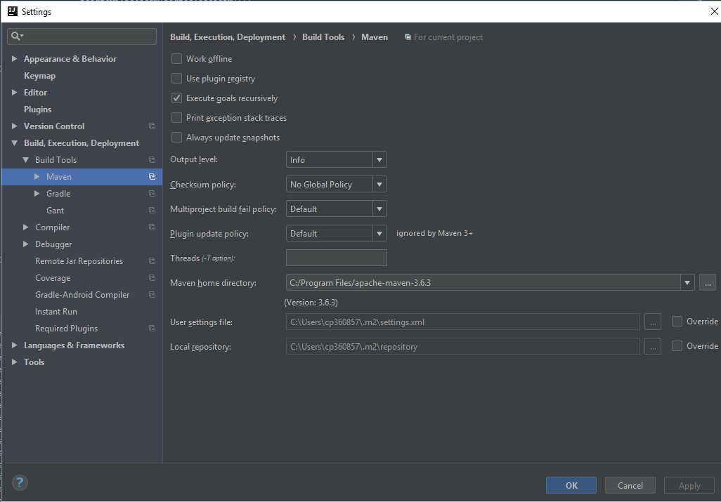

Settings. Select git and point the path to the git.exe file when it is installed in your program files.

